Ono’s Tale of Two Prefectures
February 5, 2014 by LMCC
Here is a brief introduction to both the Kedaka line of Tottori Prefecture and the Dai 7 Itozakura line of Shimane Prefecture (with a mention of Okayama Prefecture’s claim on Dai 7 Itozakura).
The Kedaka line started, appropriately enough, with the birth of bull Kedaka, himself, in Tottori Prefecture in 1959. Kedaka produced a number of fine lines and bulls, including the Harumi line (Shimane Prefecture). Kedaka cattle were bred as pack animals, so they were valued for their ability to transport things (produce, in this case) over great distances, rather than their ability to do heavy work over short distances. There was less of an emphasis on farm chores in Tottori Prefecture as there was in Hyogo Prefecture, so the cattle were built differently. Tottori Prefecture cattle didn’t need large forequarters but did need to be good grazers. Good grazing meant strong mothering instincts, something the Harumi line is widely appreciated for.
The Dai 20 Hirashige line, established in 1974, is the most famous offshoot of Kedaka’s genetics.
Interestingly, Dai 20 Hirashige is the product of a father-daughter mating. As a result, his “inbreeding coefficient” is 25 percent, at a minimum. An inbreeding coefficient estimates the percentage of identical genes that have been inherited or are likely to be inherited from an offspring’s parents.
An inbreeding coefficient can range from 0 to 100 percent, but 25 percent is considered to be high. Ideally, the inbreeding coefficient should not be higher than 12-15 percent. The higher the inbreeding coefficient is, the greater the risk of mortality or abnormality in offspring. On the other hand, a higher inbreeding coefficient can enhance the positive traits of the two parents in the progeny.
It’s a roll of the genetic dice, but often the potential benefits are judged to be worth the possible risks.
For more information about inbreeding, line breeding and inbreeding coefficient, click here.
As the 20th century progressed, Tottori Prefecture began to provide more bulls for other prefectures — and even other continents (namely, Australia) — than it did for itself. In fact, some of the finest Tottori lines were launched outside of Tottori. For example, Hirashigekatsu, of Kagoshima Prefecture, is one of the best and most balanced bulls in current use. Taro Araki, publisher of Beef Cattle magazine, has said that Hirashigekatsu is an ancestor of half the cows in Japan.
Today, Tottori is trying to get some of its genetics back to bolster its own herds.

The Kedaka chart is as follows:
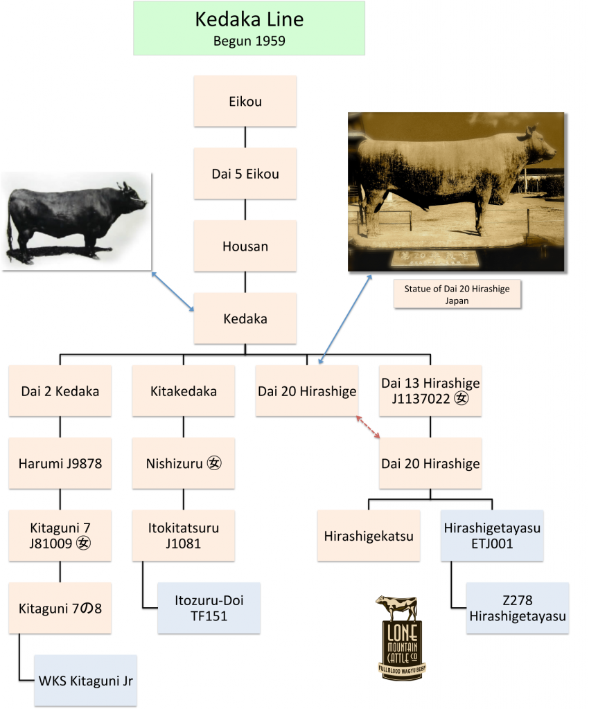
The Dai 7 Itozakura line is really two lines and two prefectures joined by a common ancestor: Dai 14 Shigeru. In Shimane Prefecture, Dai 14 Shigeru (who was born in Okayama Prefecture) was paired with a Tajima dam to create Dai 7 Itozakura. In Okayama Prefecture, descendants of Dai 7 Itozakura — Dai 6 Fujiyoshi, in particular — were used to create the Fujiyoshi line.
As Shogo Takeda wrote in the August 2007 issue of the Australian Wagyu Update, “People from Okayama Prefecture insisted that Dai 7 Itozakura originated from the Okayama line. This is because Dai 7 Itozakura’s sire (Dai 14 Shigeru) was born in Okayama. On the other hand, people from Shimane Prefecture insisted that Dai 7 Itozakura originated from Shimane, as his maternal lines originated from Shimane.”
Confusion persists.
Dai 7 Itozakura’s most famous son is, perhaps, Kitaguni 7-8, whose mother was a Kedaka dam. Thus, Kitaguni 7-8 was a Dai 7-Kedaka composite bull.
The Dai 7 Itozakura (Shimane) chart is as follows:
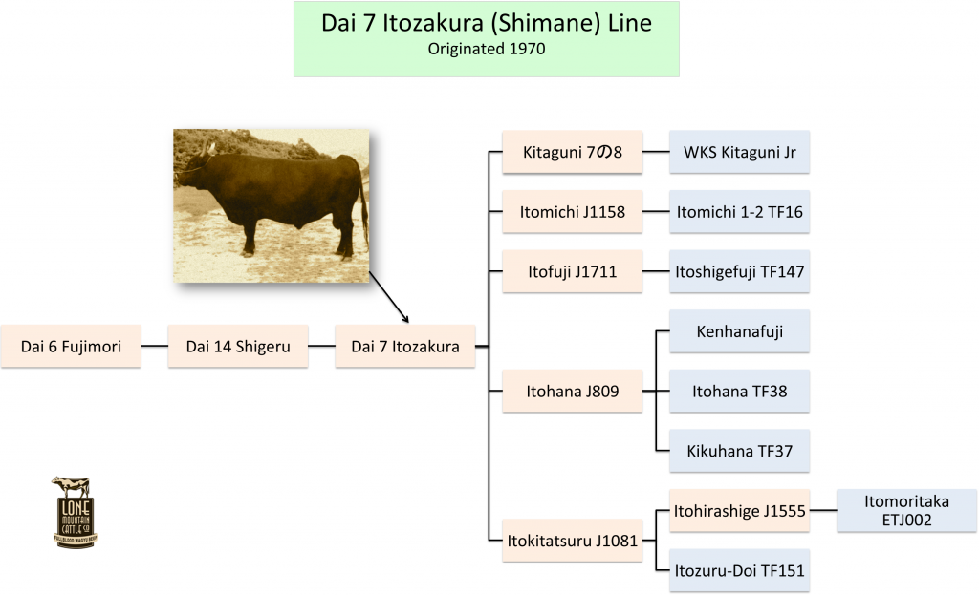

Line Breeding vs Inbreeding
February 5, 2014 by LMCC
Inbreeding is the mating of animals that are closely related to each other. Outcrossing is the mating of animals that are totally unrelated. Somewhere in the middle lies line breeding. What constitutes inbreeding and what constitutes line breeding is in the eye of the breeder.
Line breeding is highly strategized inbreeding. It is breeding to close relatives in order to lock in desirable traits. Line breeding seeks to convey outstanding genetics from one generation to another while minimizing the transfer of undesirable traits.
A so-called half-sib mating (half brother to half sister) is a popular form of line breeding.
The difference between inbreeding and line breeding lies in the degrees of separation between one half of a breeding pair and the other. Inbreeding means mating father to daughter, mother to son, and brother to sister. Line breeding involves mating more-distantly related animals, although there is a conventional wisdom that says line breeding is whatever works and inbreeding is whatever doesn’t.
The grandfather of animal breeding is 18th-century English agriculturalist Robert Bakewell. Bakewell was the first to turn away from a random approach to breeding that had ruled the roost (and the pasture and the barn) for centuries. Bakewell took control of the breeding process and introduced inbreeding (then known as “close breeding”) as a way of locking in and magnifying desirable traits.
Bakewell believed in finding the best and mating it with the best. Everything breeders do today owes a debt to Bakewell.
The terms “inbreeding coefficient” and “coefficient of inbreeding” both refer to a mathematical formula devised by the late geneticist Sewell Wright. It is used for determining just how close, genetically, certain animals are. The inbreeding coefficient (IC) calculates the probability that “both genes of a pair in an individual are identical by descent,” according to a definition that has been shared online by breeders of alpacas, pit bulls and many other disparate animals.
What is considered high varies from animal to animal, and breed to breed. In racehorses, an inbreeding coefficient of 5 percent is considered high. In Wagyu, it’s anything over 15 percent. The higher the percentage, the greater the potential benefits and risks. In Japan, especially in Hyogo Prefecture, intensive and extensive line breeding over the course of several hundred years has been used on Wagyu to lock in certain traits.
At first, Japanese breeders were just trying to create the best draft animals. They had no way of knowing, of course, that the physical traits they appreciated in cattle raised for work would one day be the same traits that breeders would appreciate in cattle raised for beef.
Hyogo Prefecture’s aggressive and long-lived line-breeding strategy was cast into high relief in a 2006 calf-market survey of 62,000 Japanese Black Wagyu. The average IC at the Hyogo Prefecture market was a whopping 21.7 percent, whereas the average IC for Tottori calves (Tottori being a prefecture where outcrossing has been practiced of late to a much greater degree) was 6.8 percent.
Courtesy of Lone Mountain Cattle Company

